**SODV2999 - SOFTWARE DEVELOPMENT CAPSTONE**

**PROPOSAL FOR**   
   
**PRODUCT SAMPLING WEBSITE**

***GROUP MEMBERS:***

***Aditi Sharma***

***Angadbir Singh Uppal***

***Ankool Kaur***

***Kamalpreet Kaur***

***Nikita Jalota***

***Princess Girlie Billones***

**DESCRIPTION OF THE PROJECT** 

Launching brands and services can be a daunting task in today’s business environment. Competition is fierce in almost every trade. To carve out your own niche in a highly competitive market, you need to align your business plane with your marketing plan from the get-go. So that is why we are creating a website to help in branding the products and for the promotion of business.

 Sampleroo is the project we are launching that allows product users to connect with the brands on product's interest, samples and development. This project will help solve many problems that big brands are facing. It will allow direct feedback, targeted the audience, and solve the marketing problem.

As our main goal is to promote the product’s visibility in the marketplace and to ensure longevity and sustainable success of the brands by constantly reviewing the results and revising specific strategies for the promotion of brands and marketing campaigns.

**DESCRIPTION OF THE ISSUE YOU ARE ADDRESSING**

Customer’s today is influenced by several elements beginning right from the identification of how the brand’s logo to how and where they encountered the promotional messages. So, in this aspect, we would say that these are the issues need to be addressed:

* There is a gap in direct communication with brands and customers.
* Brands spend millions of dollars guessing who use their products.
* Users have no input in product development
* Accumulating the appropriate workforce for the company
* Less awareness of brand.  Increase brand awareness so that customers are clear about your product, if they do not know, they can’t buy our stuff.

Defining these problems, marketing the business involves convincing these customers to use particular products because of their suitability over the competitors. 

**DETAILED DESCRIPTION OF THE PROPOSED SOLUTION**

To find solutions to the mentioned problems and in order to improve the branding and marketing strategies for the company we imposed some solutions:

* Connect brand with the users to achieve input, feedback and loyalty.
* Identify customers who can assist in improving products, producing testing and future product development.
* This is also a big challenge to find right workers having appropriate skills required for the job and marketing skills too.
* Advertise more on social media as everyone uses smartphones these days and create blogs to aware them about the product.

**PROJECT MANAGEMENT PLAN**

***Scope of our project:*** The main aim of our project is to make a good marketing product, which would be beneficial for the customers. By this project we would like to make a connection between brand and the users. In addition, the scope for the project contains, the frontend, develop a backend for the website and log in for new and old customers. Moreover, the main objective of the project would be to achieve feedback and loyalty.

***Timeline:***

* ***Front end:***3 weeks
* ***Backend part 1:***4 weeks (profile, surveys, recommendations, campaigns and log ins for the users)
* ***Backend part 2:*** 4 weeks (communication, feedback, review system, dashboard)
* ***Revisions: 2 weeks***(if their would be some alterations to be made on the said website)

***Division of work:***The whole project will be divided among all of us equally. We will be distributing front end and back-end work among all.

**GIT REPOSITORY SET UP FOR THE PROGRAM**

https://github.com/pgbillones/SODV2999-Project-Sampling-Website-Group

**JIRA PROJECT MANAGEMENT SETUP**   
<https://samplerooproject.atlassian.net/jira/software/projects/SW/boards/1>

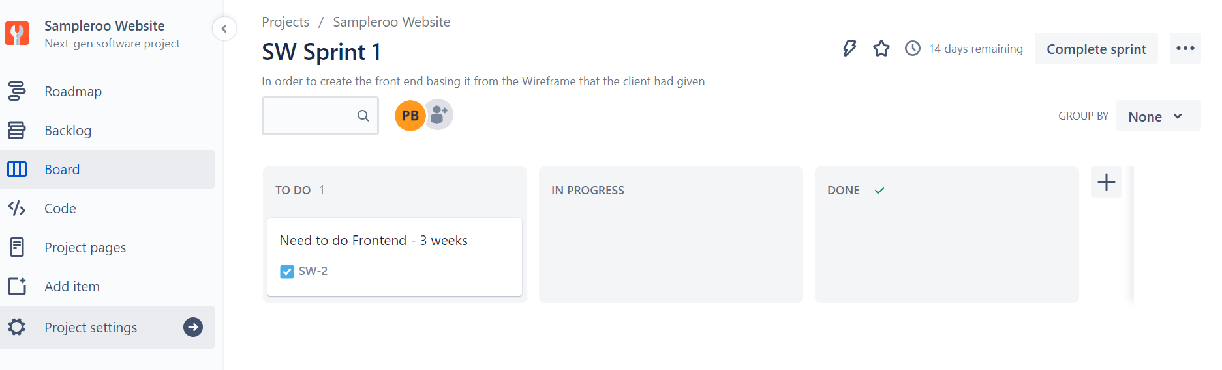

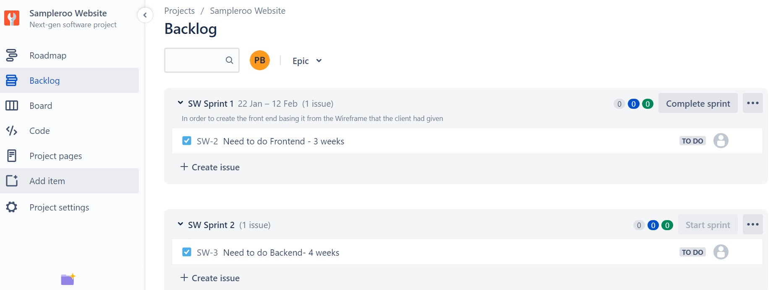

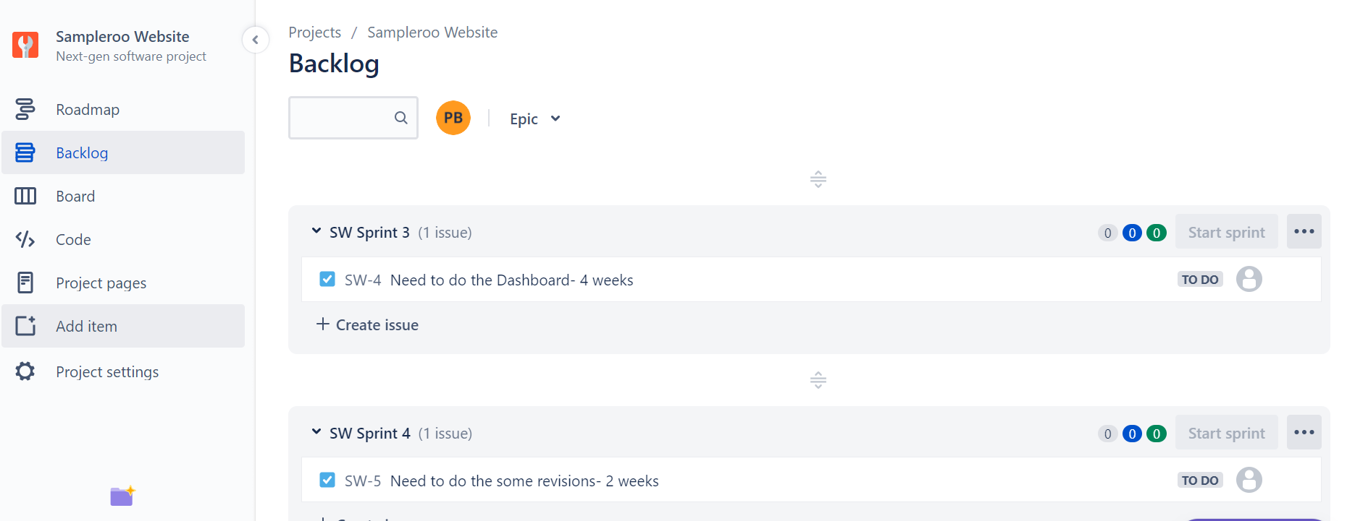

**PROJECT SPRINT**

Firstly, for front end we have three weeks overall. In which we are planning to contribute first two weeks for the completion of front-end part and the other week will be for revision and corrections.

For the back-end part 1, we will be having time limit of five weeks. In which we are planning to complete some given tasks in about four weeks, giving ourselves one week to put everything together.

For the back-end part 2, we are hoping to have a time limit of five weeks as well. Last weeks are going to be consumed for communicating with customers getting feedback from them about product. At the end a week will be contributed to review system.

**OTHER DETAILS THAT MAY BE NECESSARY TO CONVINCE A CLIENT THAT YOUR IDEA IS THE BEST POSSIBLE SOLUTION:**

Every member of our group has experience in writing code in html, CSS and JavaScript. Developing the website using these languages will make the best use of our skill set.